**DAILY ONLINE ACTIVITIES SUMMARY**

|  |  |  |  |  |  |  |  |  |
| --- | --- | --- | --- | --- | --- | --- | --- | --- |
| **Date:** | **02/06/2020** | | | | | **Name:** | **SUJAYA** | |
| **Sem & Sec** | **IV sem & B section** | | | | | **USN:** | **4AL18CS090** | |
| **Online Test Summary** | | | | | | | | |
| **Subject** | | **-** | | | | | | |
| **Max. Marks** | | **30** | | **Score** | | | **-** | |
| **Certification Course Summary** | | | | | | | | |
| **Course** | **Cloud Foundations** | | | | | | | |
| **Certificate Provider** | | | **Greatlearning academy** | | **Duration** | | | **4.5 hours** |
| **Coding Challenges** | | | | | | | | |
| **Problem Statement1:** Write a Java program to find Perfect Sum Problem  **Problem Statement2:** Write a program in java, an array of integer data to be initialized. During the initialization, if a user enters a value other than integer value, then it will throw InputMismatchException exception. On the occurrence of such an exception, your program should print “You entered bad data.” If there is no such exception it will print the total sum of the array. | | | | | | | | |
| **Status: Executed** | | | | | | | | |
| **Uploaded the report in Github** | | | | | **YES** | | | |
| **If yes Repository name** | | | | | **Online-coding** | | | |
| **Uploaded the report in slack** | | | | | **YES** | | | |

Online Test Summary: No internals conducted today.

Online Certification Course Summary: In today’s session I learnt about Introduction to Virtualization, Containers and VM’s PaaS and Service Taxonomy and also Price Economics, Data Velocity and Distributed Computing.

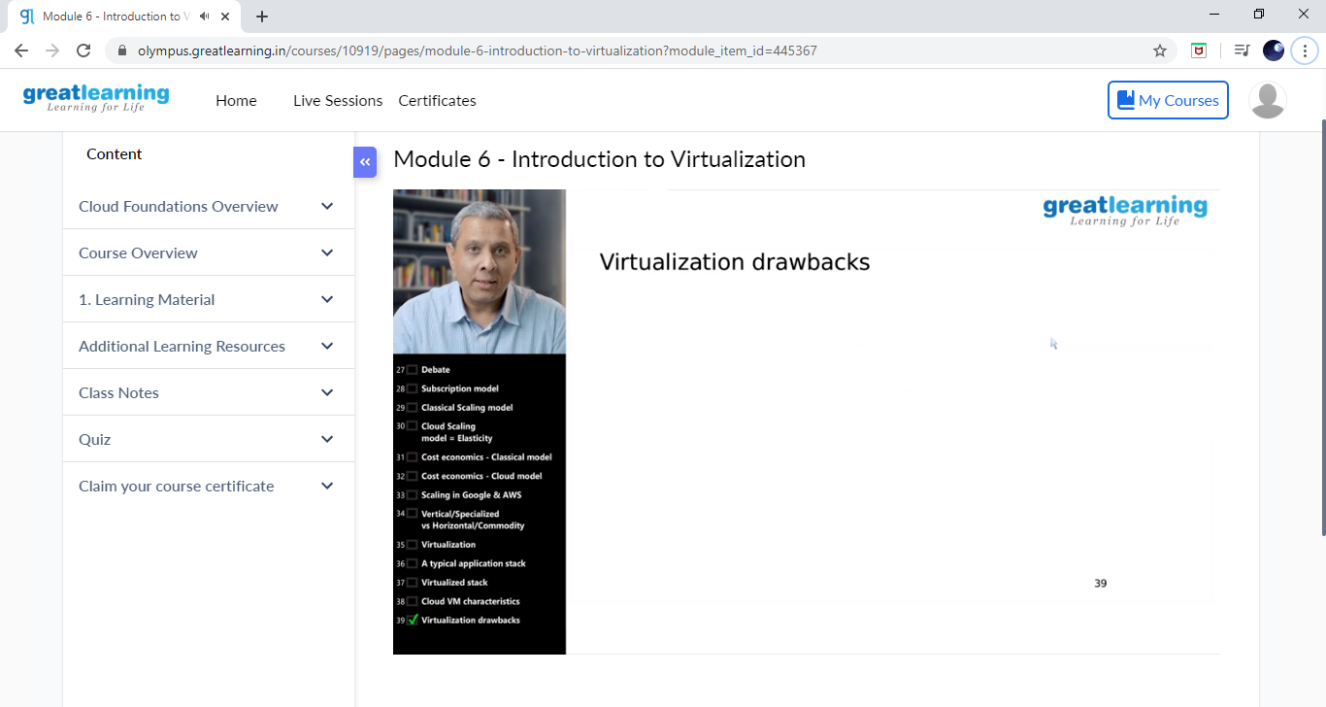

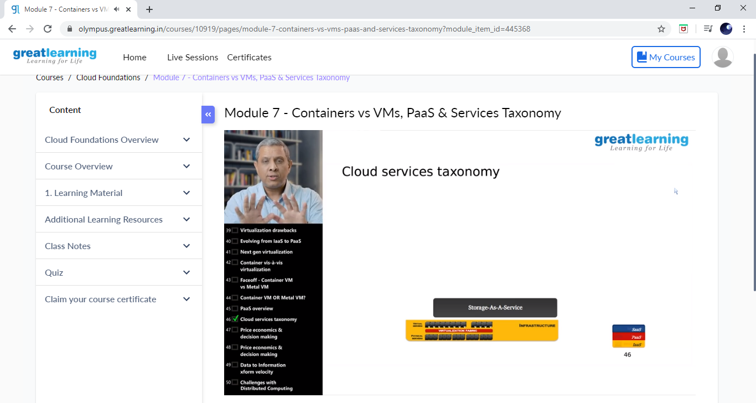

These are the Snap shots of today’s sessions.

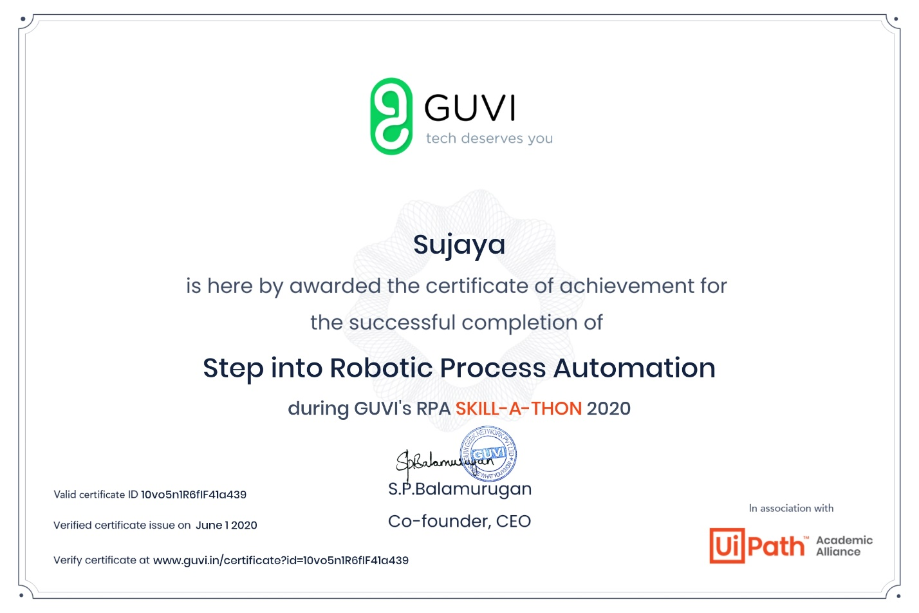

This is the certificate of achievement for the successful completion of Step into Robotic Process Automation during GUVI’s RPA SKILL-A-THON 2020.

Online Coding Summary: **Today I had received one program from prof. Shilpa CSE Dept. the other from Prof. Reena Lobo CSE Dept. and Prof.Venkatesh CSE Dept. The program is mentioned above in the coding challenges(pg.01). I have also uploaded it to my Github repository.**

**This is the snap shot of my Github repository** were I have uploaded the code. File name is **B**.java, PerfectSum.java and inversion.c

